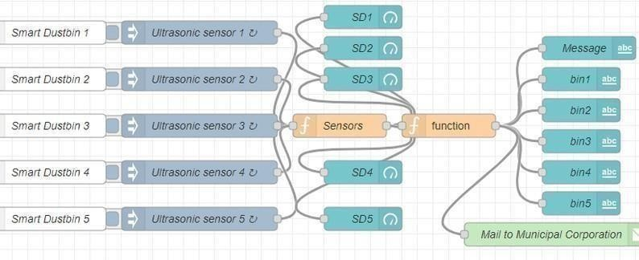Develop A Web Application Using Node-RED Service

**Develop The Web Application Using Node-RED**

|  |  |
| --- | --- |
| Team ID | PNT2022TMID05693 |
| Project Name | SMART WASTE MANAGEMENT SYSTEM FOR METROPOLITIAN CITIES |
| Maximum Marks | 4 Marks |